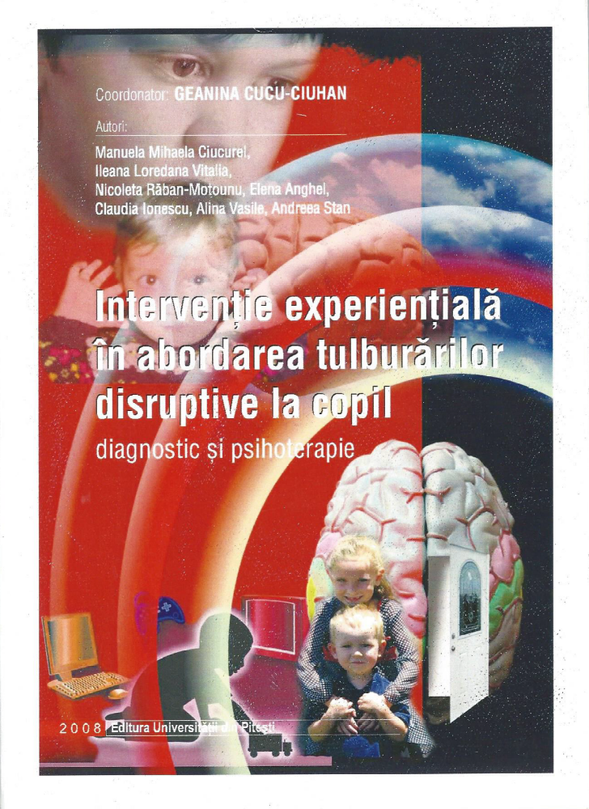
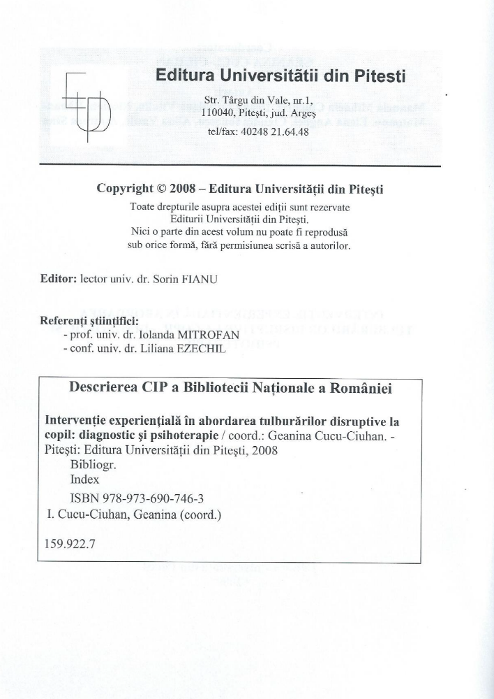

BIBLIOGRAFIE

American Psychiatric Association (1994), Diagnostic and Statistical Manual of Mental Disorders (4th edition), Washington, D.C. Author.
Barlow, D. (2005), Whats New About Evidence-Based Assessment, Psychological Assessment, Nr.3, 308-311
Bellack, A.S. (Editor), Hersen, M. (Editor), Children & adolescents: clinical formulation & treatment, Comprehensive Clinical Psychology Volume 5, Pergamon, 1 edition, 1998.
Bettlheim, B. – “Psychanalyse des contesde fees”, Robert Laffont, Paris, 1976, p. 24
Bratton S.C., Ray D., Rhine T. and Jones L. (2005), The Efficacy of Play Therapy With Children: A Meta-Analytic Review of Treatment Outcomes, Professional Psychology: Research and Practice, Vol. 36, No. 4, 376–390.
Brigit M. van Widenfelt, Treffers, Philip D.A.; de Beurs, Edwin; Siebelink, Bart M.; Koudijs, Els. (2005). Translation and Cross-Cultural Adaptation of Assessment Instruments Used in Psychological Research With Children and Families. Clinical Child and Family Psychology Review, vol.8, no.2, p. 135- 146
British Association of Dramatherapists – în SchaterG, Courtney R. – “Drama in Therapy”, Volume I: Children, Drama Book Specialist (Publishers), New York, 1981, p. 55;
Busseri, Michael A.; Tyler, John D. (2003). Interchangeability of the Working Alliance Inventory and the Working Alliance Inventory, Short Form. Psychological Assessment, vol.15, no.2, 193-197
Corey G. - ”Groups – Process and Practice”, Brooks Cole Publishing, Corey L., Company Montery
Cucu-Ciuhan, G. (2001). Psihoterapia copilului hiperactiv: o abordare experienţială. Editura SYLVI, Bucureşti.
Cucu-Ciuhan, G. (2005). Cercetarea calitativa in psihologie, Editura SYLVI, Bucureşti.
Cucu-Ciuhan, G. (2006). Eficienţa psihoterapiei experienţiale la copilul hiperkinetic: un studiu de validare, Editura SPER, Bucureşti.
Cucu-Ciuhan, G. (2003). Introducere în cercetarea psihologică, Editura Universităţii Naţionale de Apărare „Carol I” Bucureşti.
Cucu-Ciuhan, G. (2000). Psihologia şcolarului mic: dezvoltare normală, psihopatologie şi psihoterapie, Editura SYLVI Bucureşti.
Dalley, T. –“ Art Psychotherapy Groups” în Dwivedik – “Group work with Children and Adolescents”, Jessica Kingsley Publishers, London and Bristol, Pennsylvania, 1996, p. 137;
De Boo G., Prins, P. (2007), Social incompetence in children with ADHD: Possible moderators and mediators in social-skills training, Clinical Psychology Review 27, 78–97
Dunkle, John H.; Myrna L. Friedlander. (1996). Contributions of Therapist Experience and Personal Characteristics to the Working Alliance. Journal of Counseling Psychology, vol.43, no.4, 456-460
European Comission, 2005, Green Paper: Improving the mental health of the population: toward a strategy on mental health for the European Union, Health and Consumer Protection, Directorate-Genaral, Brussels, 14.10.2005, COM(2005)484, http://europa.eu.int/comm/dgs/health_consumer/index_en.htm
Eysenck. H.G., An Exercise in Mega-Silliness, American Psychologist, may 1978, pp.517.
Flake, Rebecca, Lorch, Elizabeth, Milich, R. (2007), The Effects of Tematic Importance on Story Recall among Children with Attention Deficit Hyperactivity Disroder and Comparison Children, Journal of Abnormal Child Psychology, Nr. 35, 43-53
Frank, Jerome D.,Therapeutic components shared by all psychotherapies. In Harvey, John H. (Ed); Parks, Marjorie M. (Ed). (1982, 1989). Psychotherapy research and behavior change., Master lecture series, Vol. 1. (pp. 9-37). American Psychological Association.
Golu P. - ”Fenomene şi procese psihosociale”, Bucureşti, Ed. Ştiinţifică şi Enciclopedică, 1989, p.137
Hair H.G. (2005), Outcomes for Children and Adolescents After Residential Treatment: A Review of Research from 1993 to 2003, Journal of Child and Family Studies, Vol. 14, No. 4, December, pp. 551–575.
Hartman, C.A., Rhee, S.H., Willcutt, E.G., Pennington, B.F. (2007). Modeling Rater Disagreement for ADHD: Are Parents or Teachers Biased? in Journal of Abnormal Child Psychology. no. 35, p. 536–542.
Horvath A.O., Greenberg, L.S. (1989), Development and Validation of the Working Alliance Inventory, Journal of Counseling Psychology, Vol. 36, No. 2, 223-233.
Horvath, Adam O. (2001). The Alliance. Psychotherapy, volume 38, number 4, p. 365-372
Horvath, Adam O.; Leslie S. Greenberg. (1989). Development and Validation of the WAI. Journal of Counseling Psychology, vol.36, no.2, 223-233
Irwin, E – “Play, Fantasy, and Symbols: Drama with Emotionally Disturbed Children” în Schather, G.; Courtney, R. “Drama in Therapy”, Volume I:Children, Drama Book Specialists (Publishers), New York, 1981, p. 113;
Irwin, E; Rubin, J.; Shapira, M. – “Art and Drama: Parners in Therapy” în Schather, G.; Courtney, R. “Drama in Therapy”, Volume I: Children, Drama Book Specialists (Publishers), New York, 1981, p. 197;
Jackson, D.A., King, A.R. (2004). Gender Differences in the Effects of Oppositional Behavior on Teacher Ratings of ADHD Symptoms. in Journal of Abnormal Child Psychology. Vol. 32, No. 2, pp. 215–224.
Jung, C.G. (1999a), Simboluri ale transformării, vol. I şi II, Editura Teora, Bucureşti
Jung, C.G. (2003), Arhetipurile şi inconştientul colectiv, Editura Trei, Bucureşti
Kazdin A. (1991), Effectiveness of Psychotherapy With Children and Adolescents, Journal of Consulting and Clinical Psychology, Vol. 59, No. 6, 785-798.
Kazdin A., Marciano P., Whitley M. (2005), The Therapeutic Alliance in Cognitive–Behavioral Treatment of Children Referred for Oppositional, Aggressive, and Antisocial Behavior, Journal of Consulting and Clinical Psychology, Vol. 73, No. 4, 726–730. (ISI)
Kepner, J. – “Body process: A gestalt approach to working with the body in psychoterapy”, New York, Gardner Press, 1987, p. 30;
Lis A., Zennaro A., Mazzeschi C. (2001), Child and Adolescent Empirical Psychotherapy: Research A Review Focused on Cognitive-Behavioral and Psychodynamic-lnformed Psychotherapy, European Psychologist, Vol. 6, No. 1, March, pp. 36-64, Hogrefe & Huber Publishers.
Loughran, S.B. (2003). Agreement and Stability of Teacher Rating Scales for Assessing ADHD in Preschoolers. in Early Childhood Education Journal, Vol. 30, No. 4, p. 247-253.
Manual de diagnostic şi statistică a tulburărilor mentale (ediţia a patra revizuită). DSM – IV- TR 2000. Editat în limba română de Asociaţia Psihiatrilor Liberi din România, Bucureşti 2003, Coordonator ştiinţific prof dr. Aurel Romilă.
Maria Eduarda Duarte. (2005). Assesment and “The Global Research Village”: Adapting Psychological Instruments. International Journal for Educational and Vocational Guidance, 5: 163-173
Mills,C.G., Crowley,J.R. (1986), Therapeutic Metaphors for Children and the Child Within, Bruner/Mazel Publishers, N.Y.
Mitrofan I., Vladislav E. – “Psihoterapia copilului centrată pe metode experienţial - expresive” în Mitrofan I. – “Psihoterapia experienţială”, Editura Infomedia, Bucureşti, 1997.
Mitrofan, I., -“Psihoterapie – Repere teoretice, metodologice şi aplicative”- Editura SPER, 2008
Mitrofan, I., Vladislav, E., Cucu-Ciuhan, G. (2001), Psihopatologia, psihoterapia şi consilierea copilului, Ed. SPER, Bucureşti.
Mitrofan, Iolanda (2004), Terapia unificării, Editura SPER, Bucureşti
Mitrofan, Iolanda (coord.) (2003), Cursa cu obstacole a dezvoltării umane. Psihologie, psihopatologie, psihodiagnoză, psihoterapie centrată pe copil şi familie, Editura Polirom, Iaşi
Norcross, J.C. (2002), Psychotherapy Relationships that Work: Therapist Contributions and Responsiveness to Patients, American Psychological Association.
Oaklander, V. – “Windows to our children: Gestalttherapy to to Child and Teenager”, The Gestalt Journal Press, Highland NY, 1988, p. 140;
Oancea C. – “Psihoterapia infantilă” în V. Predescu – “Psihiatria”, vol. I, Editura Medicală, Bucureşti, 1989, p. 211;
Payne, H – “The Use of Dance Movement Therapy with Troubled Iouth” în Schaffer Ch., E. – “Innovative Interventions in Child and Adolescent Therapy”, John Willey Sons, New York, Chichester, Brisbane, Toronto, Singapore, 1988, p. 68;
Penberthy, J.K., Cox, D., Breton, M., Robeva, R., Kalbfleisch, M.L., Loboschefski, T., Kovatchev, B. (2005). Calibration of ADHD Assessments Across Studies: A Meta-Analysis Tool. in Applied Psychophysiology and Biofeedback. Vol. 30, No. 1. p. 31-51.
Richard Courtney – “Drama Assessment” în Schather G., Courtney, R. – “Drama in Therpy”, Vol. I: Children, Drama Book Specialists (Publishers), New York, 1981, p. 5;
Robeva, R., Penberthy J.K., Loboschefski T., Cox, D., Kovatchev, B. (2004). Combined Psychophysiological Assessment of ADHD: A Pilot Study of Bayesian Probability Approach Illustrated by Appraisal of ADHD in Female College Students. in Applied Psychophysiology and Biofeedbac., Vol. 29, No. 1, p. 1-18.
Rosner R. I. Psychotherapy research and the National Institute of Mental Health, 1948-1980. In Freedheim, Donald K. (Ed); Freudenberger, Herbert J. (Ed); Kessler, Jane W. (Ed); Messer, Stanley B. (Ed); Peterson, Donald R. (Ed); et al. (1992). History of psychotherapy: A century of change. (pp. 113-150). American Psychological Association. xxxiii, 930 pp.
Sadock, Benjamin J. (Editor), Sadock, Virginia A. (Editor), Kaplan & Sadock's Comprehensive Textbook of Psychiatry (2 Volume Set), Lippincott Williams & Wilkins Publishers; 7th edition (January 15, 2000).
Schaffer Ch., E. – “Innovative Interventions in Child and Adolescent Therapy”, John Willey Sons, New York, Chichester, Brisbane, Toronto, Singapore, 1988, p. 98;
Schultz, W – “Joy Expanding Human Awarness”, New York, Ever Green Black Hat, 1969;
Shirk S., Karver M. (2003), Prediction of Treatment Outcome From Relationship Variables in Child and Adolescent Therapy: A Meta-Analytic Review, Journal of Consulting and Clinical Psychology, Vol. 71, No. 3, 452–464.
Smith M.L., Glass G. (1977), Meta-Analysis of Psychotherapy Outcome Studies. American Psychologist, September, pp. 752-760.
Speiser, Vivien M., Speiser, Ph. (2007), An Arts Approach to Working With Conflict, Journal of Humanistic Psychology, Nr. 47, 361-366
Strupp, Hans H.; Howard, Kenneth I.A brief history of psychotherapy research.In Freedheim, Donald K. (Ed); Freudenberger, Herbert J. (Ed); Kessler, Jane W. (Ed); Messer, Stanley B. (Ed); Peterson, Donald R. (Ed); et al. (1992). History of psychotherapy: A century of change. (pp. 309-334). American Psychological Association. xxxiii, 930 pp.
Tracey, Terence J; Anna M Kokotovic. (1989). Factor structure of the Working Alliance Inventory. Psychological Assessment - A Journal of Consultng and Clinical Psychology, vol.1, no.3, 207-210
Vladislav, Elena (2007), Folosirea psihodiagnosticului experienţial în cazul unui copil cu fobie socială, Revista de Psihoterapie Experienţială, Nr.37, 25-35
Wakschlag, L.S., Leventhal, B.L., Briggs-Gowan, M.J., Danis, B., Keenan, K., Hill, C., Egger, H.L., Cicchetti, D., Carter, A.S. (2005). Defining the “Disruptive” in Preschool Behavior: What Diagnostic Observation Can Teach Us. in Clinical Child and Family Psychology Review. Vol. 8, No. 3, p. 183-201.
Weinberger Joel (2002), Short Paper, Large Impact: Rosenzweig’s Influence on the Common Factors Movement. Journal of Psychotherapy Integration, Vol. 12, No. 1, 67–76.
Weinberger Joel (2002), Short Paper, Large Impact: Rosenzweig’s Influence on the Common Factors Movement. Journal of Psychotherapy Integration, Vol. 12, No. 1, 67–76.
Weiss B., Catron T., Harris V., Phung T. (1999), The Effectiveness of Traditional Child Psychotherapy, Journal of Consulting and Clinical Psychology, Vol. 67, No. 1, 82-94.
Wright, K.D., Waschbusch, D.A., Frankland, B.W. (2007). Combining Data from Parent Ratings and Parent Interview When Assessing ADHD. in Journal of Psychopathology and Behavioral Assessment, vol. 29, p. 141–148.
Zlate C., Zlate M. - ”Cunoaşterea şi activarea grupurilor sociale”, Editura Politică, Bucureşti, 1982.

